Data Preparation Documentation

1. Overview
The purpose of the data preparation phase was to transform the raw customer dataset into a clean and structured format suitable for machine learning modelling. The dataset was prepared for two main analytical tasks:
- Customer segmentation using clustering algorithms (K-Means)
- Customer churn prediction using supervised learning models
The preparation process involved data quality assessment, target variable transformation, categorical encoding, feature scaling, and preparation of the final modelling dataset.

2. Dataset Loading
The customer dataset was imported from a CSV file:
Dataset: Dataset_ATS_v2.csv
The dataset contains customer demographic information, service subscription details, account information, and churn status.
The initial dataset was loaded using the Pandas library and inspected to understand:
- Number of records
- Number of features
- Data types
- Missing values
- Duplicate records
- Feature distributions

3. Data Quality Assessment

3.1 Missing Value Analysis
A missing value assessment was performed across all attributes to identify incomplete records.
The following method was used:
df.isnull().sum()
The analysis identified whether any columns contained missing values that could affect model performance.
No null values were encountered.
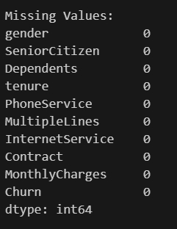

3.2 Duplicate Record Detection
Duplicate records were identified using:
df.duplicated().sum()
Duplicate records were reviewed because repeated customer entries can introduce bias into clustering and prediction models.
The dataset was checked to ensure each customer record represented a unique observation.
Some duplicate records were identified; however no duplicate records were dropped as we do not require to have a unique record at this instance.

4. Target Variable Transformation
The original churn variable was provided as categorical values:
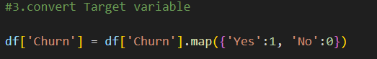

5. Categorical Feature Encoding
Machine learning algorithms require numerical input; therefore, categorical variables were converted into numerical representations.
Two encoding techniques were applied.

5.1 Binary Categorical Encoding
Binary categorical variables containing two possible categories were transformed using Label Encoding.
The following features were encoded:
- Gender
- Dependents
- Phone Service
- Multiple Lines
Example:
Feature | Original | Encoded
Gender | Male | 1
Gender | Female | 0
Encoding was performed using:
LabelEncoder()
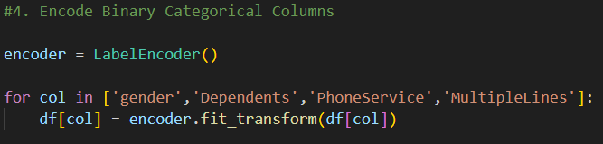

5.2 One-Hot Encoding
Multi-category variables were transformed using one-hot encoding.
The following attributes were encoded:
- Internet Service
- Contract Type
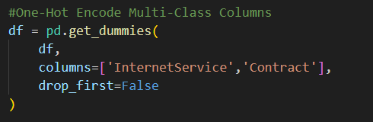

6. Feature Scaling
Numerical features were standardised to ensure all variables contributed equally during clustering.
The following numerical features were scaled:
- Tenure
- Monthly Charges
Standardisation was performed using: StandardScaler()

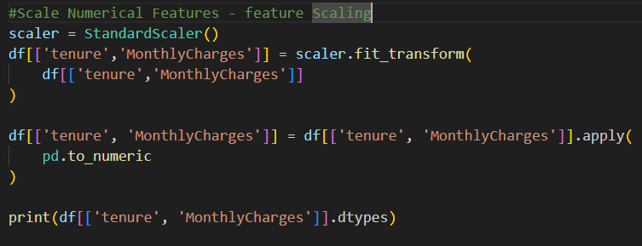
Scaled values were maintained as floating-point numbers to preserve numerical information.

7. Boolean Conversion
After one-hot encoding, some categorical variables were stored as Boolean values.
These Boolean columns were converted into integer format:


This would convert – True to 1 and False to 0 which was obtained after one hot encoding

9. Final Prepared Dataset
The final prepared dataset contains:
- Numerical customer features
- Encoded categorical variables
- Standardised numerical attributes
- Binary representation of categorical variables
The prepared dataset was saved as:
customer_churn_preprocessed_Data.csv

10. Data Preparation Outcome
After completing the preparation process, the dataset was ready for:
Customer Segmentation
Using:
- Principal Component Analysis (PCA)
- K-Means Clustering
- Elbow Method
- Silhouette Score Evaluation

